**Instruction to fetch data of the requisite ‘Asset Size’ of the Mutual Funds from the NSE website following the steps below:**

Step 1: Go to the following link:

<https://www.nseindia.com/products/content/equities/mutual_funds/mutual_funds.htm>

Step 2: Click on the link at the bottom left corner as encircled in red.

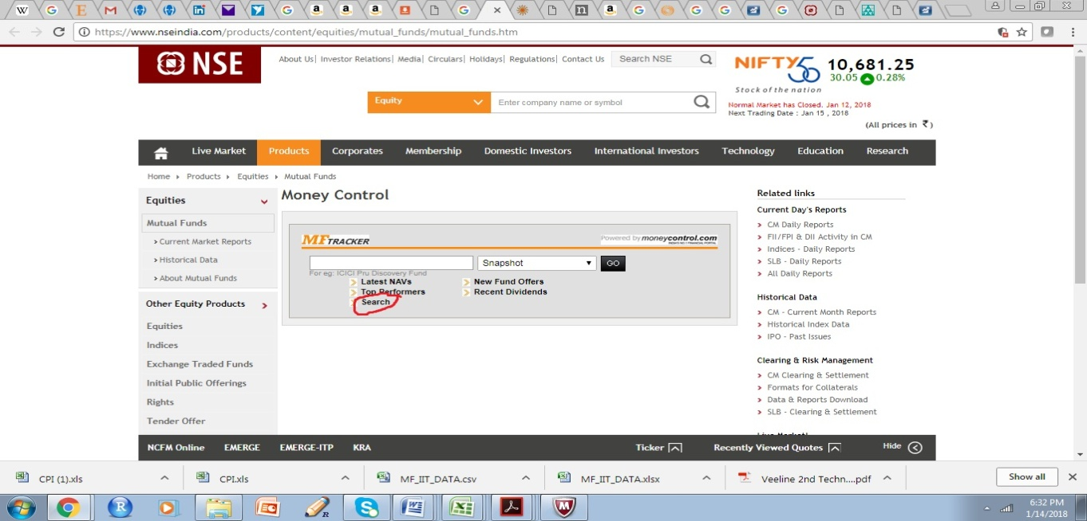

Step 3: Select Category in the List of Values in Search screen for the said Sector/ Category.

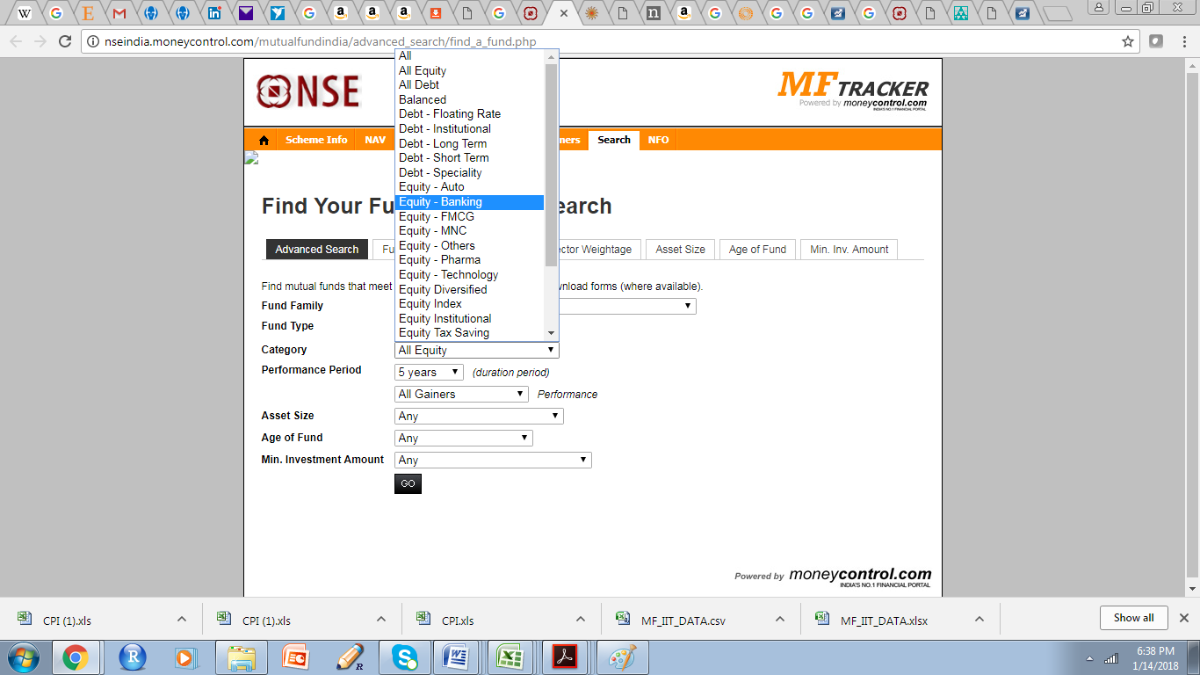

Step 4: Select a particular Scheme (Mutual Fund Product) name

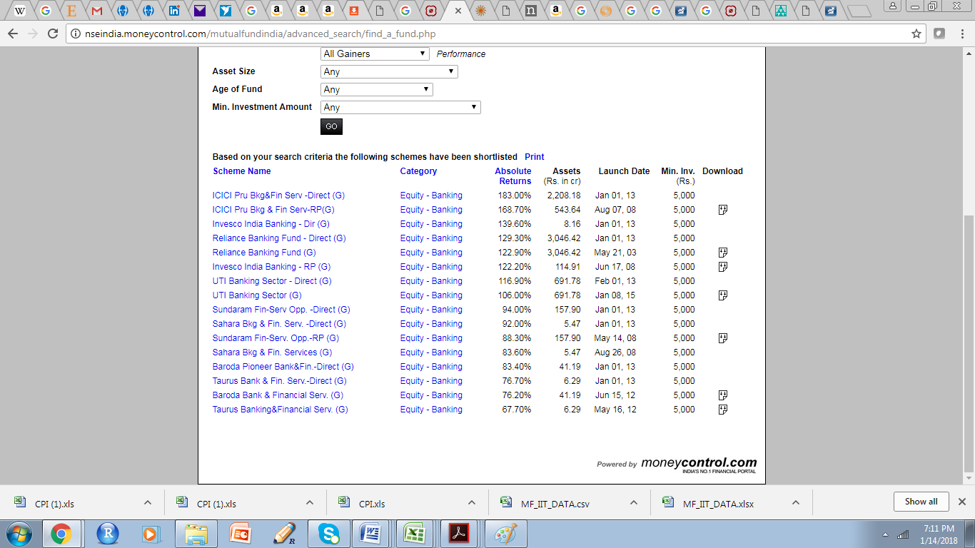

Step5: Go to Asset Size tab.

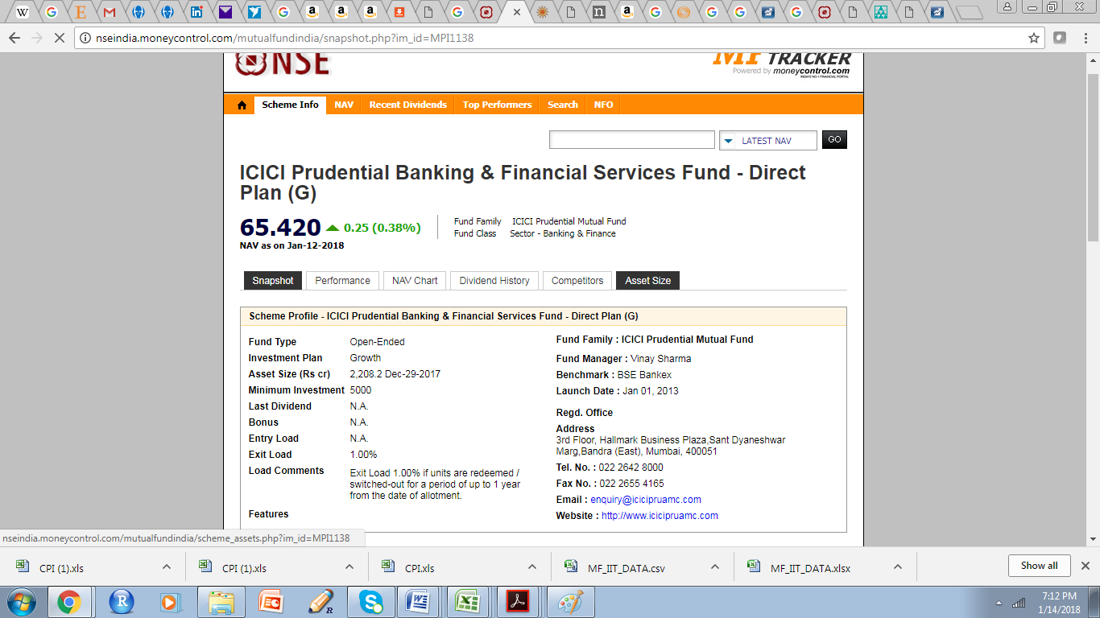

Step 6a: Note down the information from Snap Shop tab – Minimum Investment, launch Date, etc.

Step 6b: Select the period (1 Jan 2013 to 31 Dec 2017)

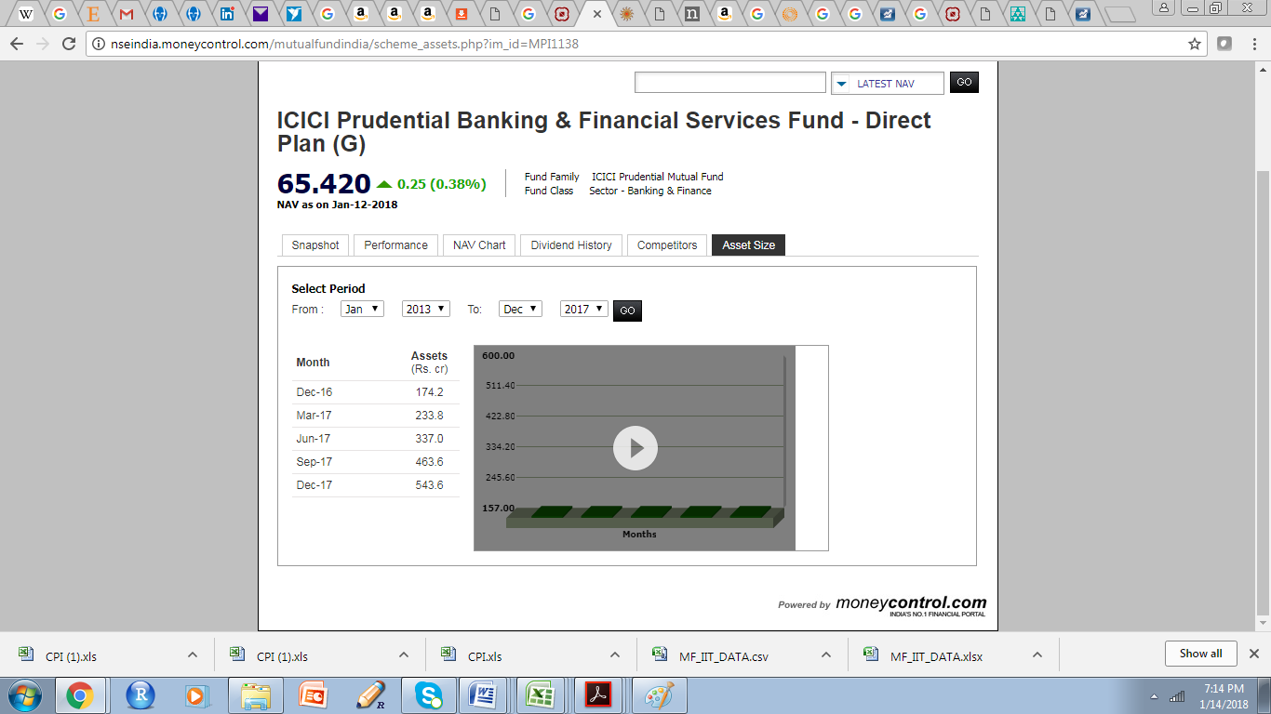

Step 7: You will get the quarter wise data for asset size for the particular period.

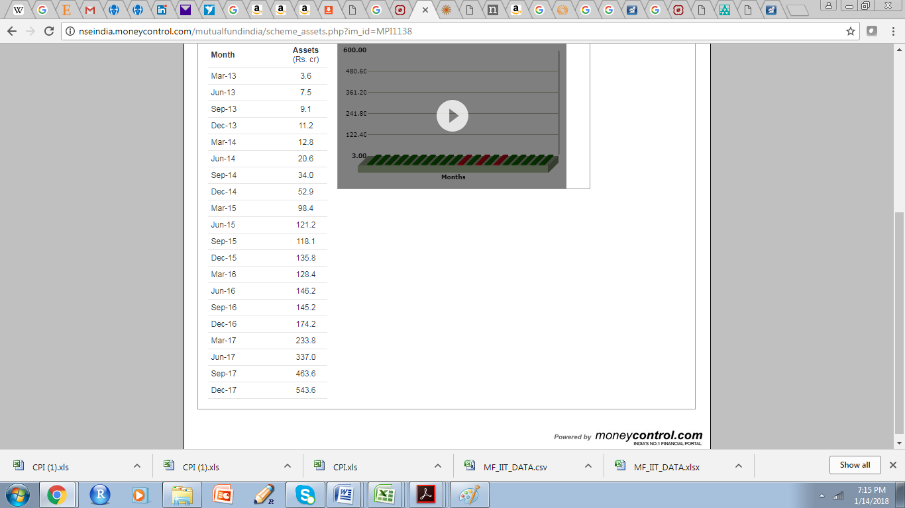

Step 8: Follow the above procedure for all the 24 given Mutual Funds. If you choose to consider few more Mutual Funds of similar category (Open Ended and AllEquity) please follow the same to get those data.